David Hatcher

74842093

Homework 3

1. * 1. Line 5 – O(1)
     2. Line 6 – O(1)
     3. Line 7 – O(1)
     4. Line 4 – O(n – delta - 1) or O(n - delta)
     5. **Total worst-time** is O(n – delta)
   1. O(lgn -1) -> O(lgn)
   2. 1. 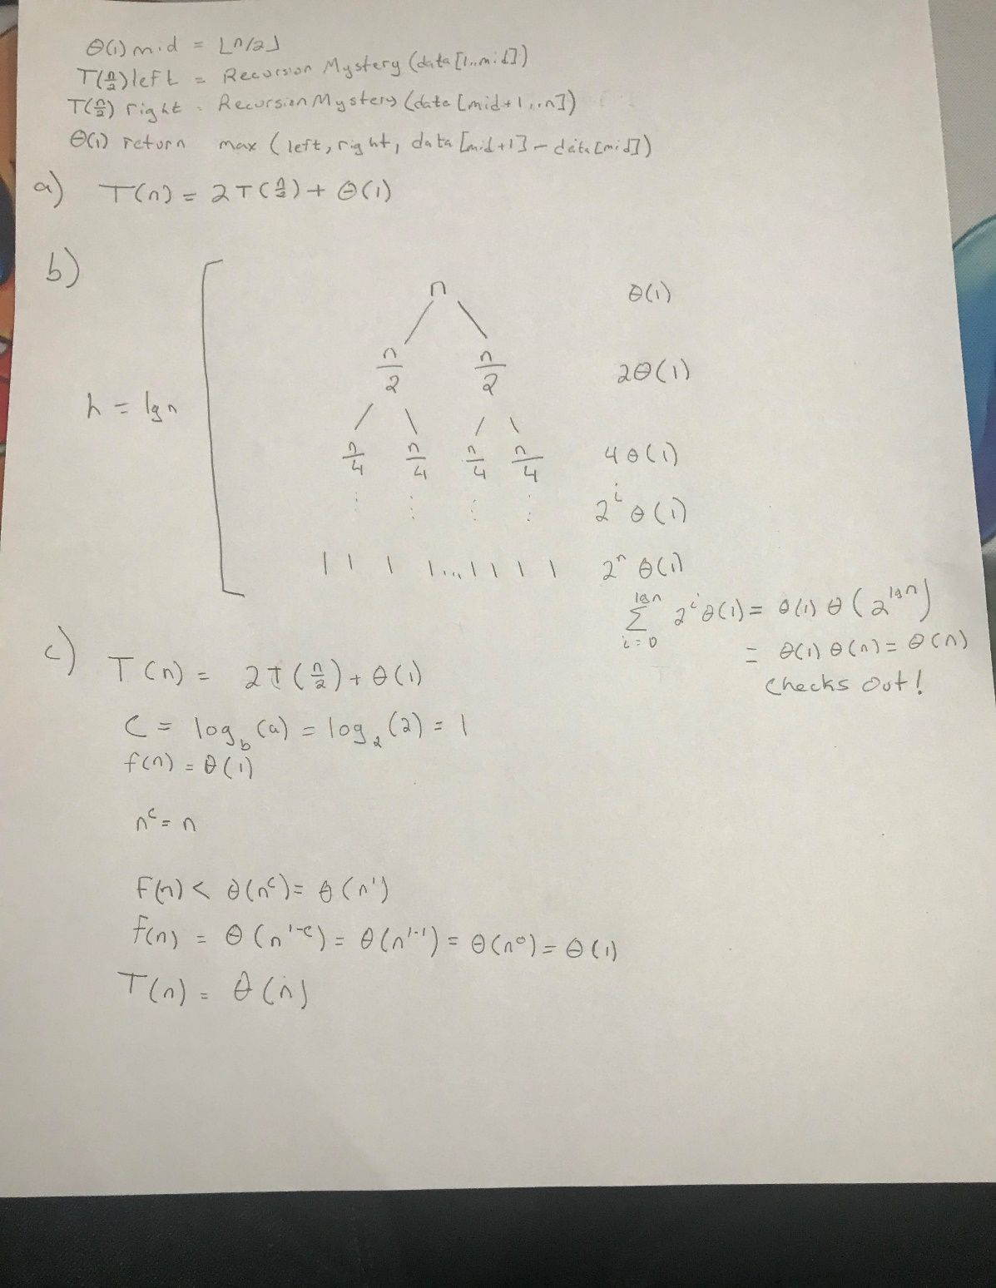O(n) – O(delta) = O(n) – O(n/2) + O(n) – O(n/4) + … + O(n) – O(1)

$\sum_{i=0}^{lgn}{n-\frac{n}{2^{i}}}=n*\sum_{i=0}^{lgn}{1-\frac{1}{2^{i}}}=n*\left(O\left(lgn\right)-O\left(1\right)\right)$

$=n*\left(O\left(lgn-1\right)\right)=n*O\left(lgn\right)=O(n*lgn)$

2.